Operator(s):___________________________________________________________________________
Experiment (check one): ______ATLAS ______CMS Data set:________________________________
Materials needed: internet-connected computer, protractor
Measurements:
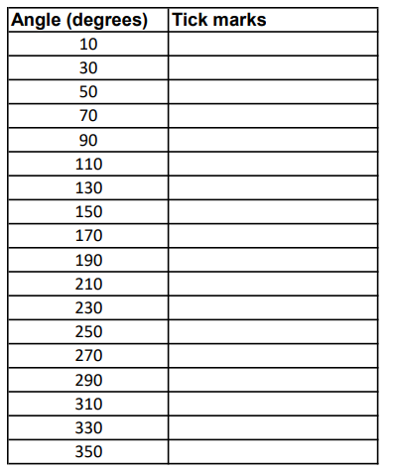

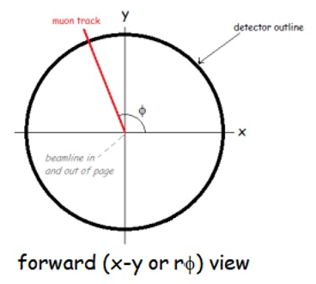

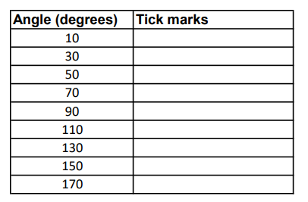
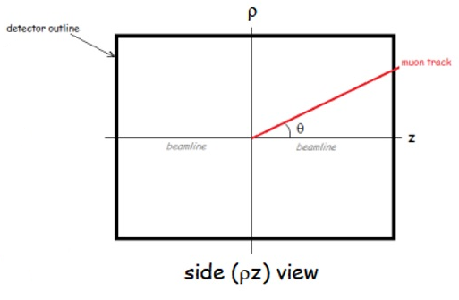

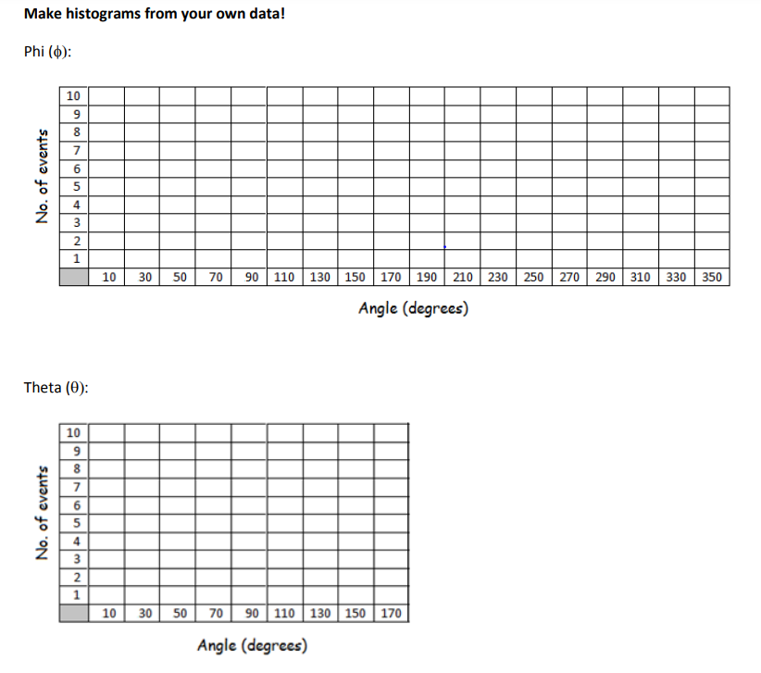
Turn in your results to your teacher, who will load it onto the Worldwide Google Sheet.
To learn more, go to http://tiny.cc/w2d2.

