Summer 2024 Quarknet Workshop at Syracuse University
The Syracuse group hosted a Quarknet workshop from Aug 14-16, 2024. The program was developed by Prof. Steven Blusk, Quarknet staff member Shane Wood, Quarknet fellow Mike Plucinski, and our lead Syracuse teachers Michael Madden and Brian Bealer. Four teachers were able to join the workshop, which included two first-time teachers.
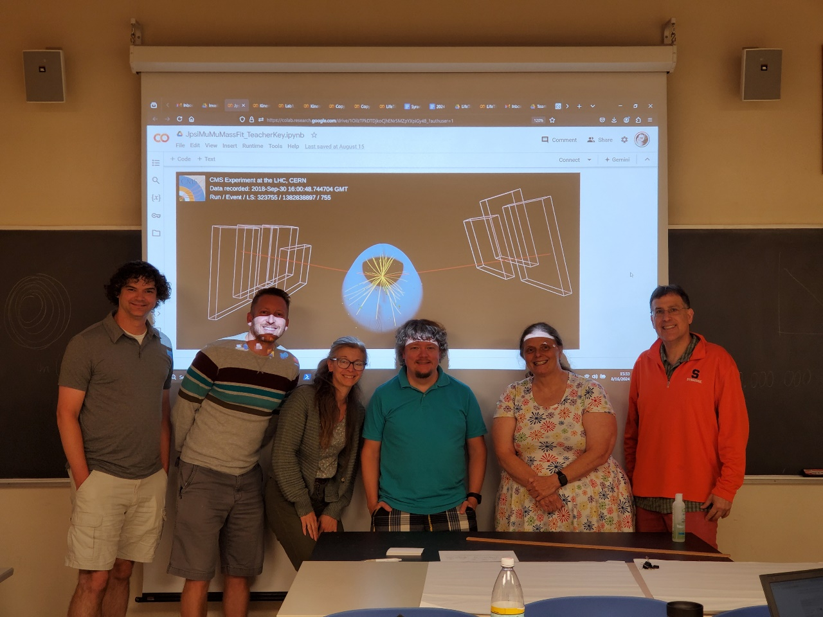
Photo showing the Quarknet 2024 participants: (From left to right): Micke Plucinski (QN fellow), Dan Kurzen, Penny Mann,
Rob Jaspersohn, Sally Mitchell, and Steve Blusk (SU). (Shane Wood was unfortunately not present on the last day)
The three-day workshop program is available at the following page
https://quarknet.org/document/syracuse-university-2024-workshop
This year, our workshop centered on learning how coding can provide a complementary and powerful way to learn about nature. We centered our activities (DAP and coding) on the amazing muon, in particular, muons in cosmic rays, and muons in decays of particles. Teachers were engaged with this material through several of the Quarknet DAP activities (Day 1). Prof. Blusk presented an overview of how muons are produced in cosmic rays, as well in decays of SM particles, such as the J/ψ and Υ resonances, and the Z⁰ boson in accelerator-based experiments.. Towards the end of day 1, each teacher set up their own cosmic ray detector (from TeachSpin) to record a sample of muon decays, with which they could measure the muon lifetime (on day 3).
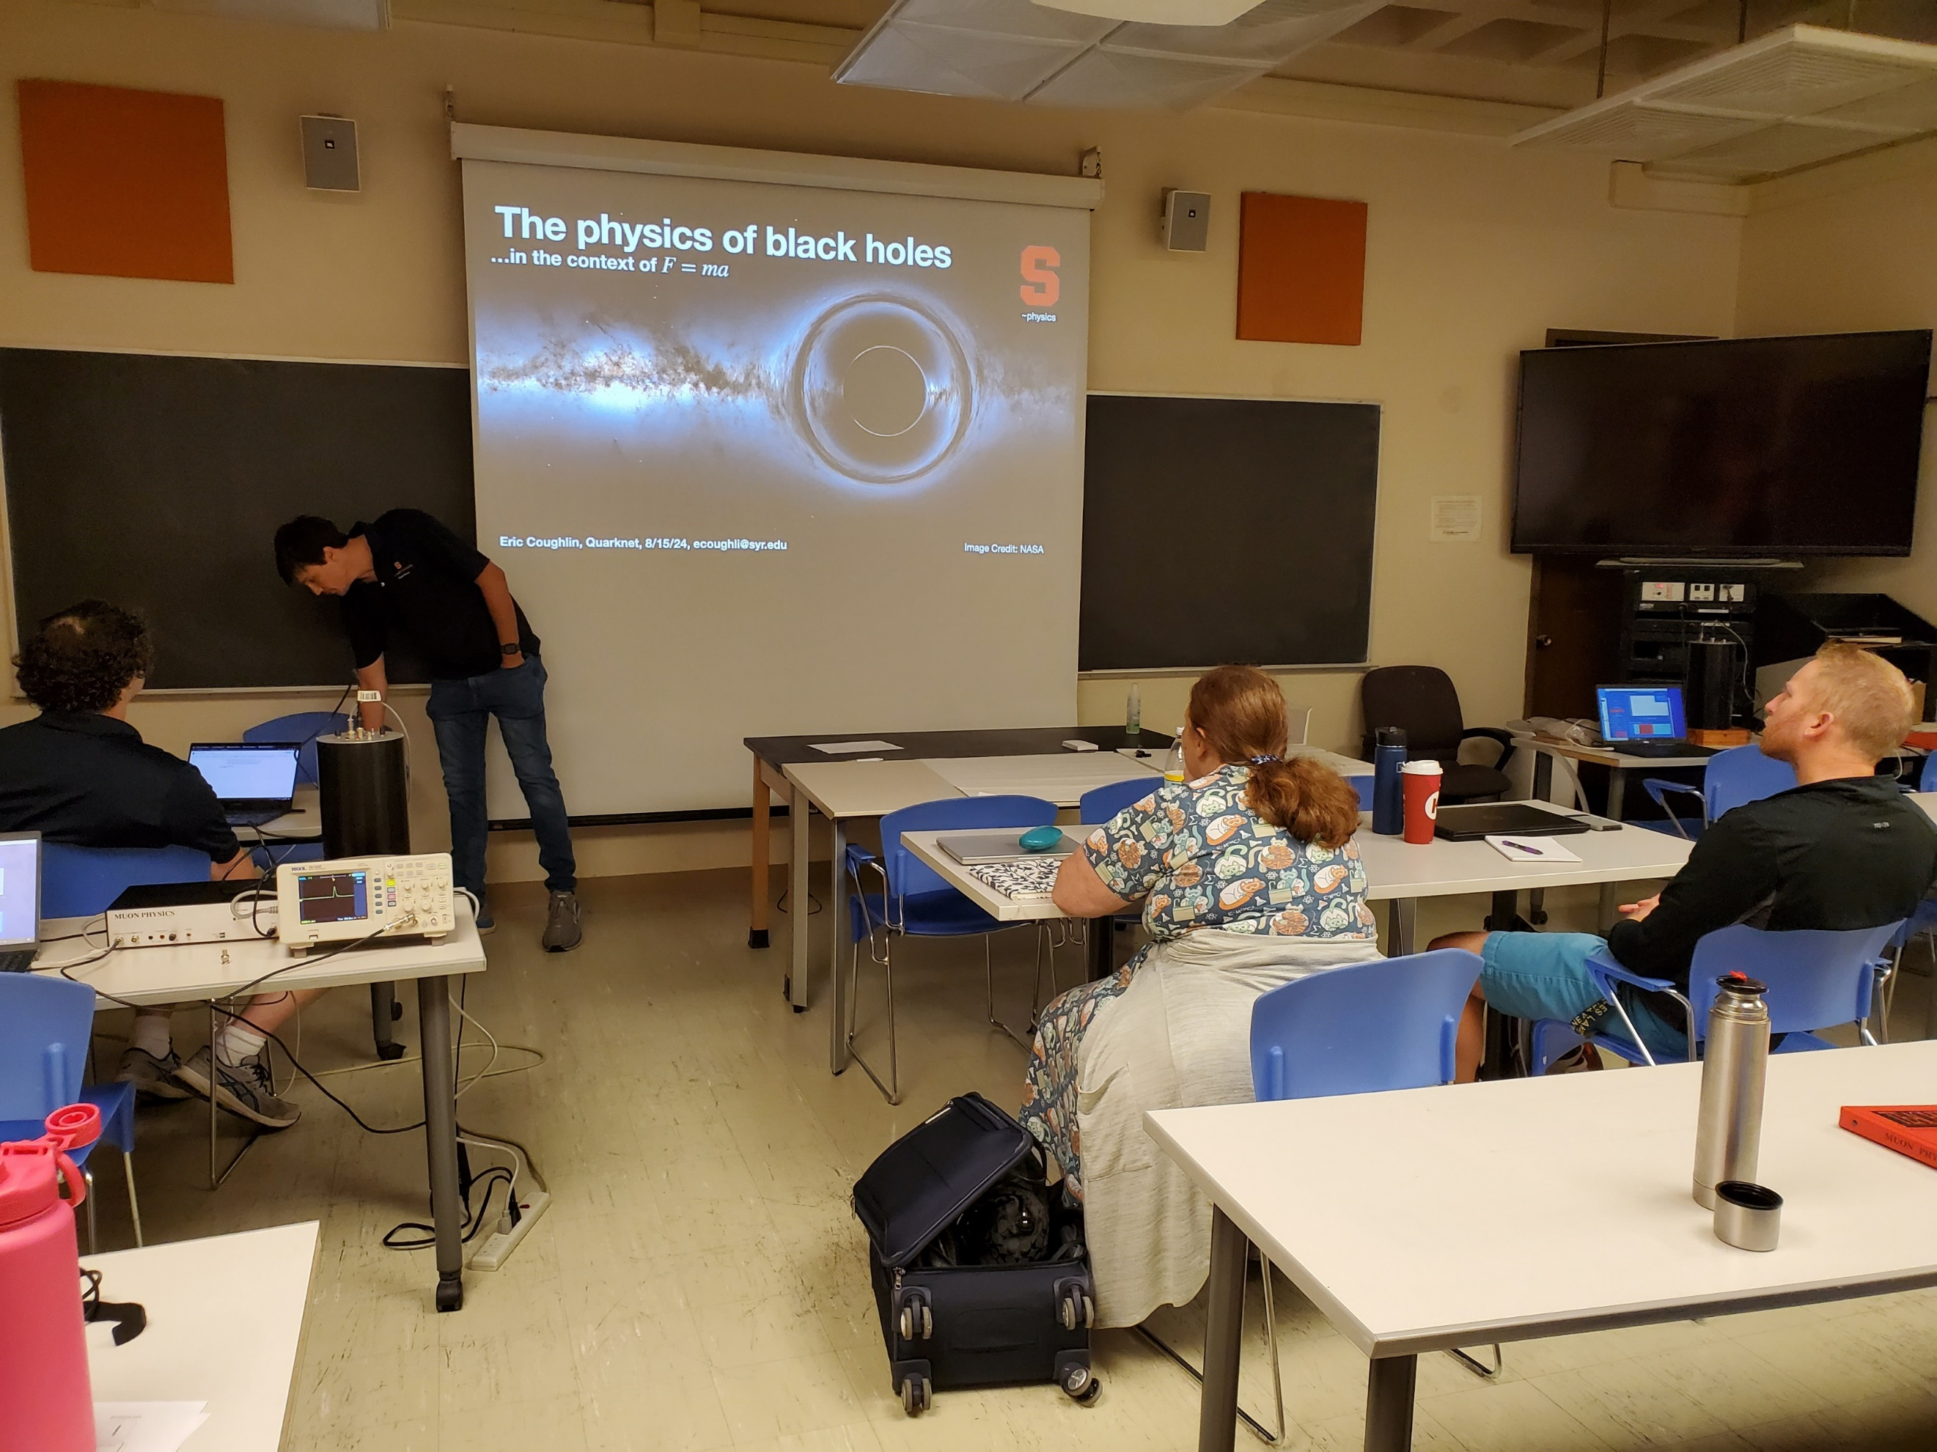
Photo (left) showing the cosmic ray detector (black cylinder) connected to the DAQ box and a scope where teachers could see the signals associated with muons passing through the detector.
Day 2 started off with an enlightening talk by SU professor Eric Coughlin on the physics of Black Holes. We then moved into the “Coding workshop” portion of the Quarknet workshop. Teachers were introduced to the Colab environment. A number of example Jupyter notebooks were provided by Mike Plucinski. Teachers has to use various features of python libraries, including: numpy, pandas, scipy, and matplotlib.pyplot,

Teachers were asked to develop an activity using Jupyter notebooks that could potentially be used in their classrooms. Teachers were given the better part of the rest of day 2 to develop their idea, to be presented at the end of day 3.
On day 3, we went through two more in-depth notebooks as a group. One of the notebooks showed how one could read in a data set and fit the data with a user-defined function. In this case, J/ψμ⁺μ⁻ decay data from the LHCb experiment was provided in the form of the momentum components of the two muons and their masses, saved in a CSV file. Teachers learned how to open the CSV file, read in the data into a pandas dataframe, use Einstein’s energy-momentum formular to compute invariant mass, plot the data, and then fit the sum of a Gaussian function and a linear background to the data to measure the J/ψ resonance mass (figure below).
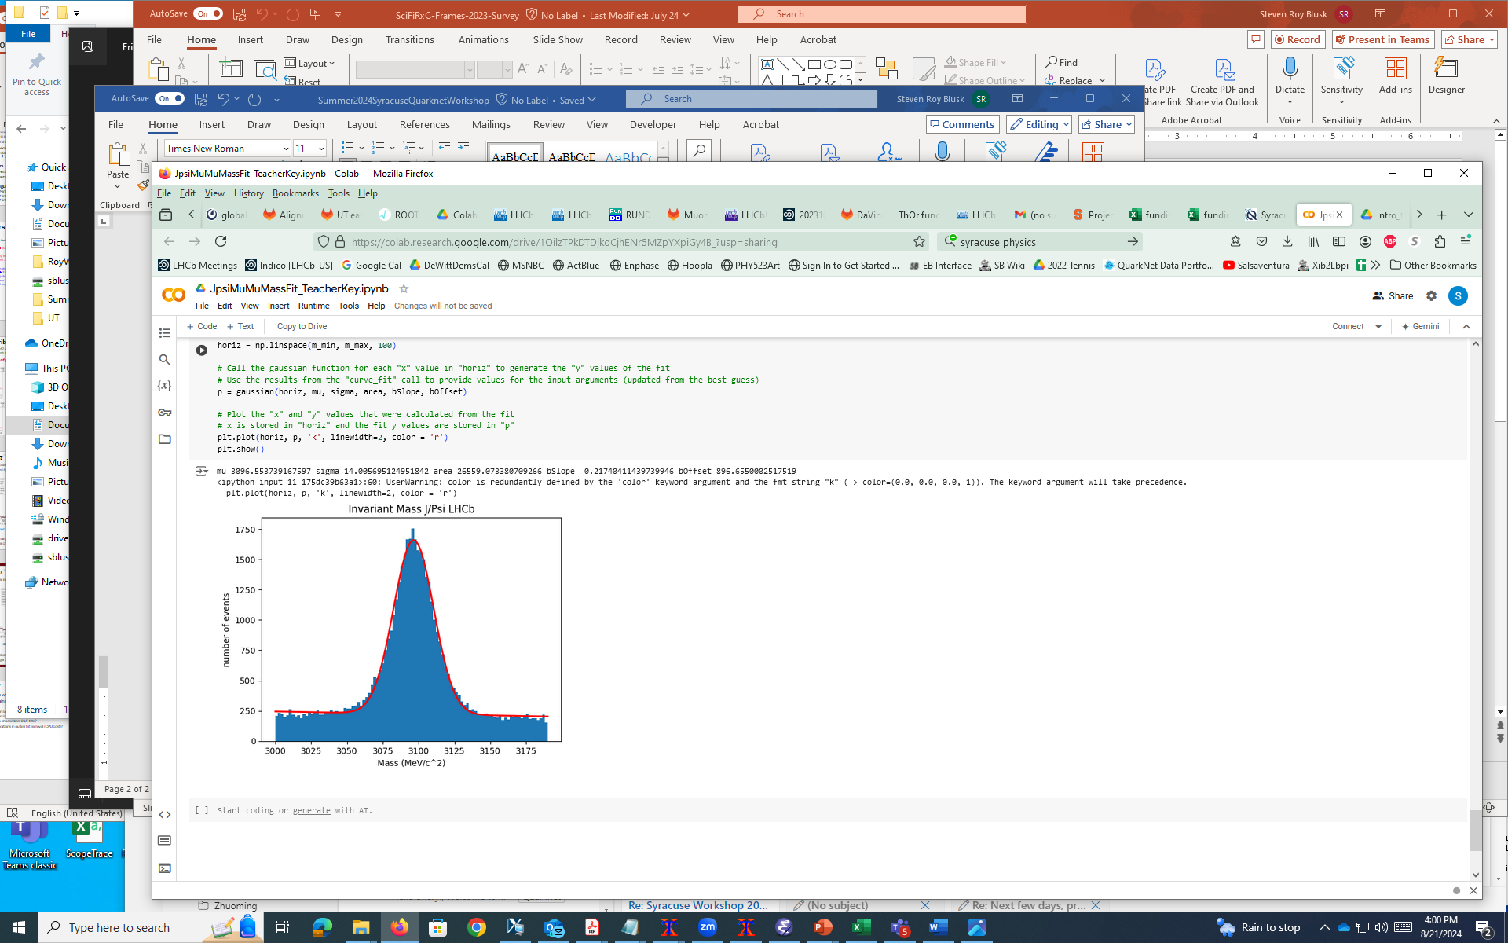
Figure (left) showing the invariant mass of a μ⁺ and μ⁻ from the LHCb experiment. A fit to the sum of a Gaussian signal shape and a linear background is superimposed.
Leading up to this, the teachers first performed a fit where they ignored the background, and they could see that the fit was poor, and did not describe the data well.

In the second activity, we used a sample of muon data collected from one of the TeachSpin detectors during the workshop. The goal was to measure the muon lifetime. Here again, the teachers had to exercise their python skills, reading in data from a CSV file, performing array computations, removing data in which there was no muon decay seen, plotting the decay time spectrum, and fitting the sum of an exponential function plus a constant value to the data. Depending on the bin sizes used and the range over which the fit was performed, teachers obtained values close to the expected value of 2.2 us. We did not stress including the uncertainties in the data points in this particular activity.
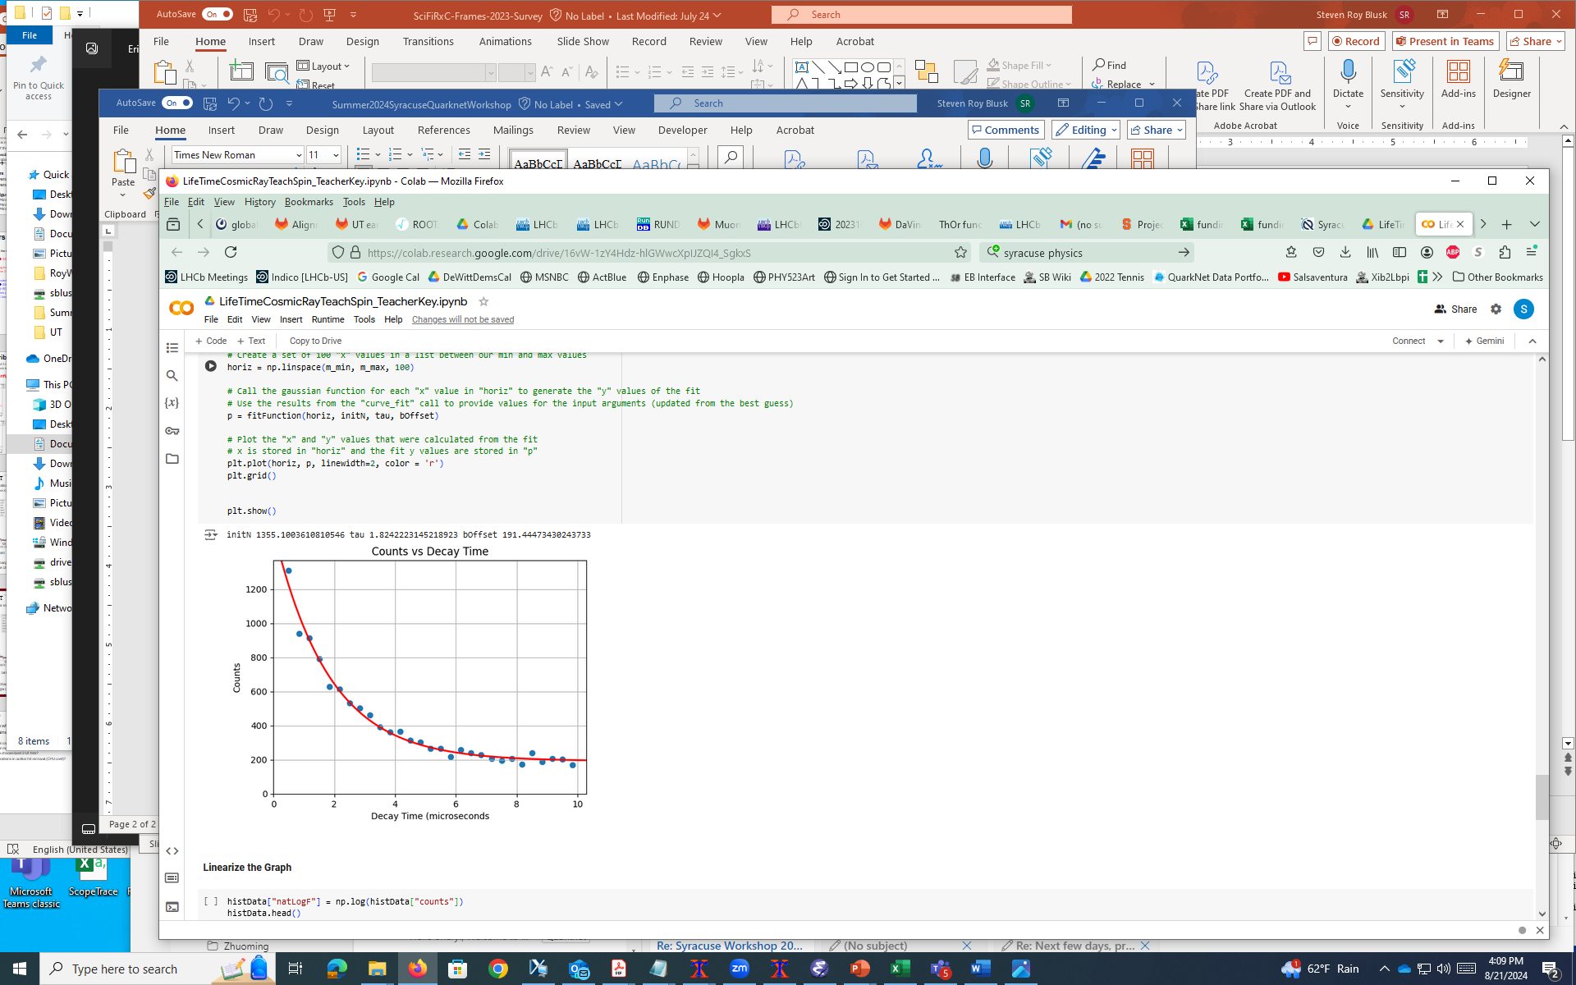
Screenshot (left) showing the last few lines of code, and below is the data and the fitted function overlaid.

Towards the end of day 3, teachers presented their own notebooks they had developed on day 2, showing how they might use Jupyter notebooks in the classroom. We discussed potential issues with using Colab (blocked due to information collection by Google), and alternatives, such as using Binder.
Overall, teachers got a first look at seeing how coding can provide an alternate way to view and understand physical laws and data they obtain in experiments. Teachers acknowledged how important computer programming skills are to students pursuing STEM-related careers, and they seemed committed to try and bring some aspects of coding into their classrooms.

