Boston QuarkNet Center
2023-2024 Annual Report

Fall Meeting – December 12, 2023.

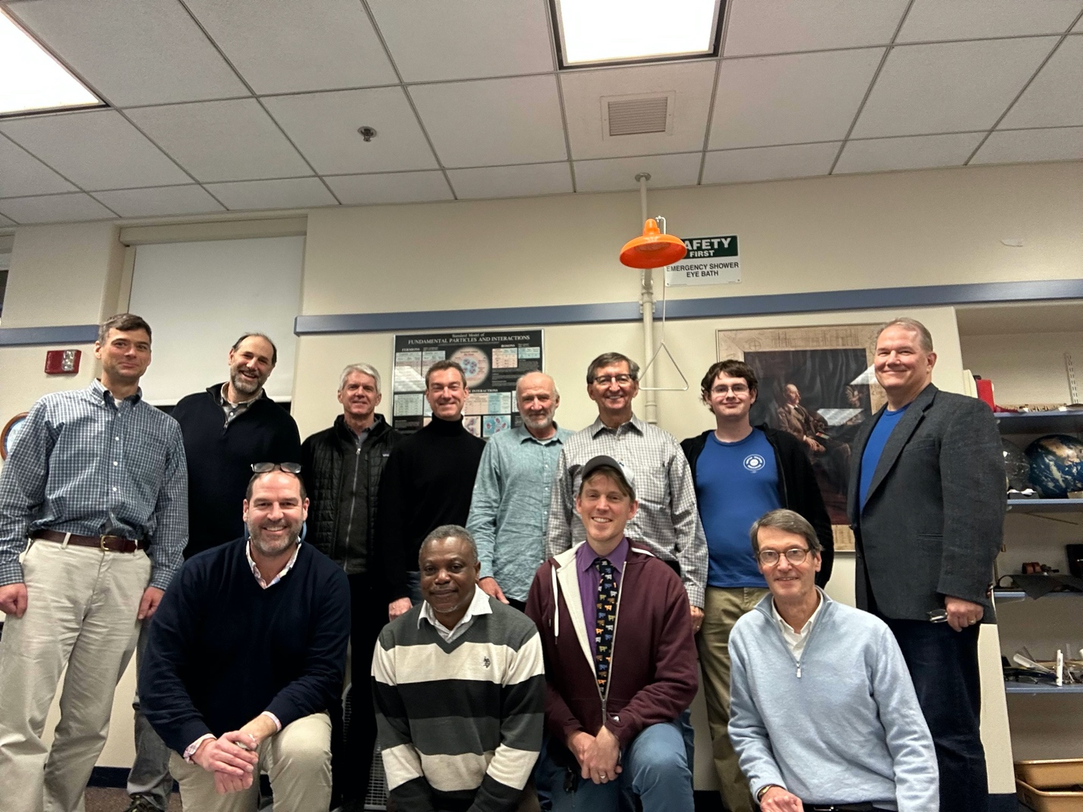

Participants in this year’s fall meeting are smiling during a break in the presentation “Relativity ad GPS: How Einstein Helps You Find Your Way Home” by Rick Dower. Kneeling from left to right are Jamison Smith, Ayo Awobode, Tim Fitzgibbon, and our Northeastern QuarkNet Mentor Darien Wood. Standing from left to right are David Kurtz, Mike Wadness, John Sherry, Teaching Professor at Northeastern Stefan Kautsch, Mike Hamblin, Rick Dower, Caelan Dammer, and Gerry Gagnon. We were also joined by Jon Kelly and Paul Martenis on Zoom.

The slides from the presentation are available on the Boston QuarkNet Group page of the QuarkNet website.

Particle Physics Masterclass at Northeastern University – March 9, 2024

Once again we had a full house of about 30 students from Massachusetts, Vermont, and Rhode Island attend our spring Particle Physics Masterclass at Northeastern University.

Students of QuarkNet teachers Mike Wadness, Tammy Kjonaas, Nicole Preiser, and Mike Hirsh analyzed images of proton collisions in the CMS detector at the LHC. Mike Wadness arranged some get-acquainted exercises for the students. Prof. Darien Wood gave an introduction to particle physics at the LHC. Then Mike talked students through some examples of CMS image analysis and students toured a physics lab before breaking for lunch with Northeastern physics grad students. After an afternoon of LHC image analysis and discussion of results, students engaged in a video conference to discuss results with other student groups engaging in similar analysis efforts. The students ended the day and headed home with a sense of satisfaction for their encounter with particle physics.
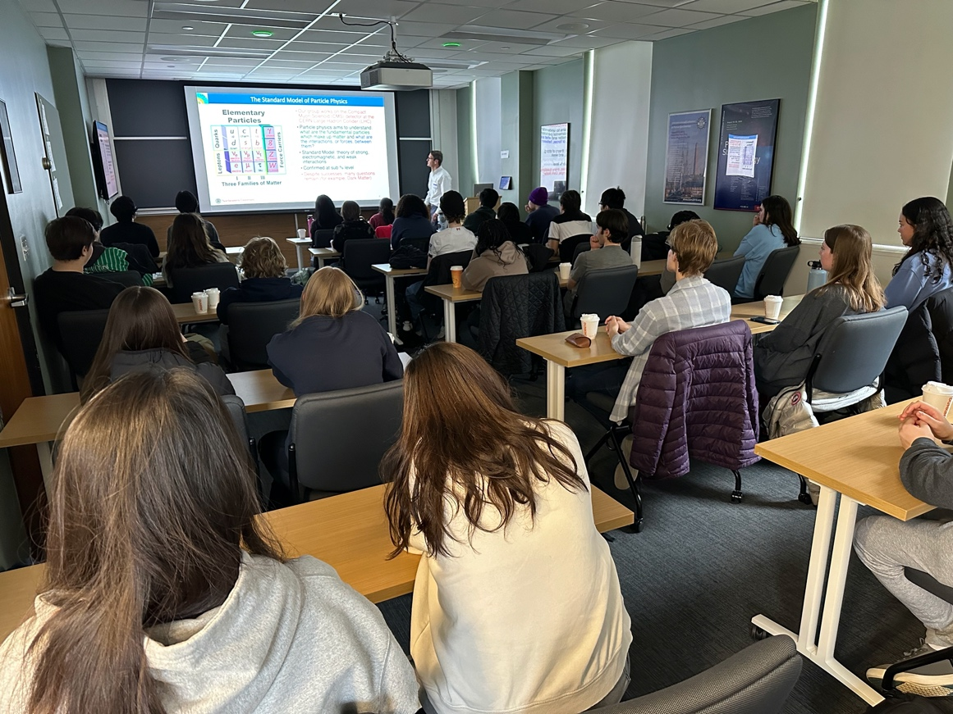

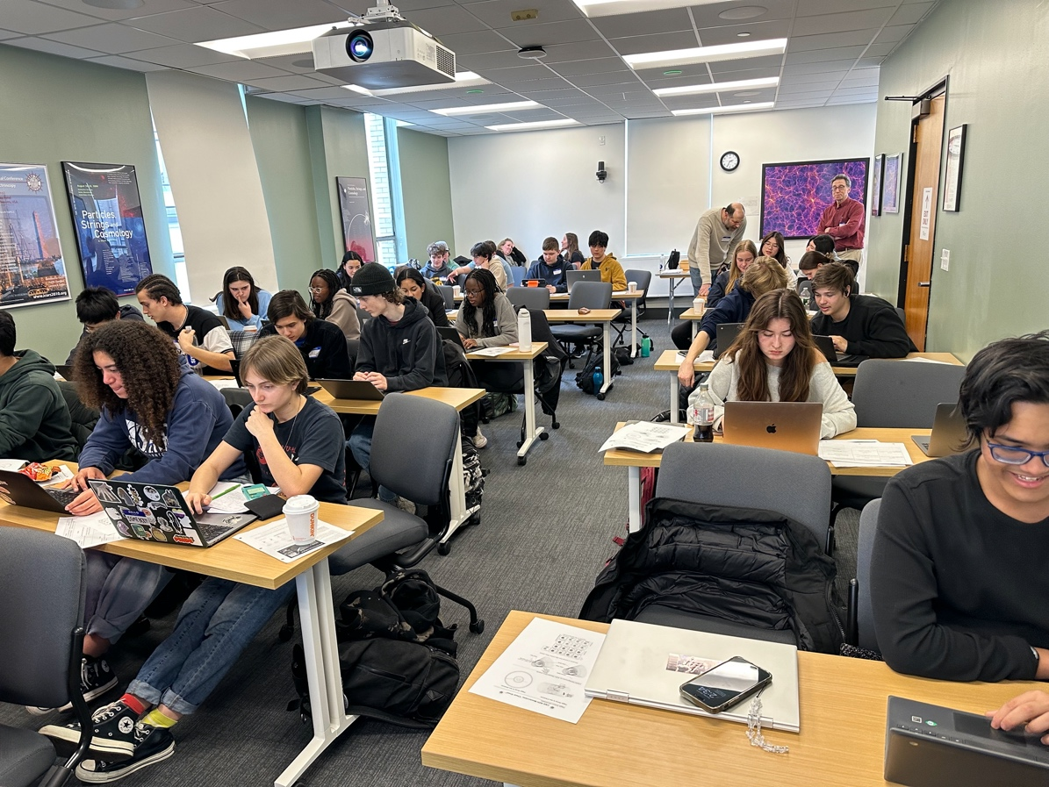

Spring Meeting – June 6, 2024
This year we took advantage of the presence in Boston of the Large Hadron Collider Physics conference in Boston during early June. Mike Wadness and Rick Dower joined Ken Cecire for the tour of the MIT Media Lab arranged by ATLAS physicist Steve Goldfarb. Mike had the pleasure of discovering that the MIT professor leading our tour was the father of two of his physics students at Medford High.

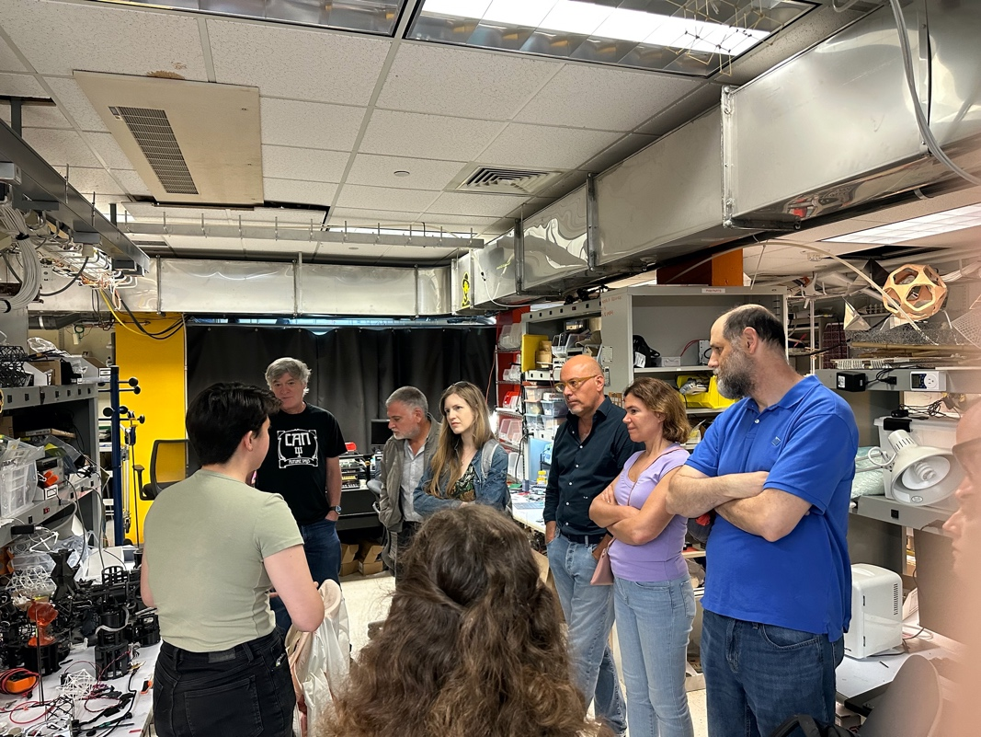

After the tour we traveled to Boston to join Mike Hirsh, John Sherry and Mark Hedstrom for conversation and dinner before attending the LHCP panel presentation Particle Physics: Where the Universe and Humanity Collide at the Boston Public Library. Sarah Demers, an ATLAS physicist from Yale, Matt Strassler, author of Waves on an Impossible Sea about quantum field theory concepts, and Katrina Miller, a New York Times science correspondent reflected on the effort to engage the public in ideas related to particle physics.

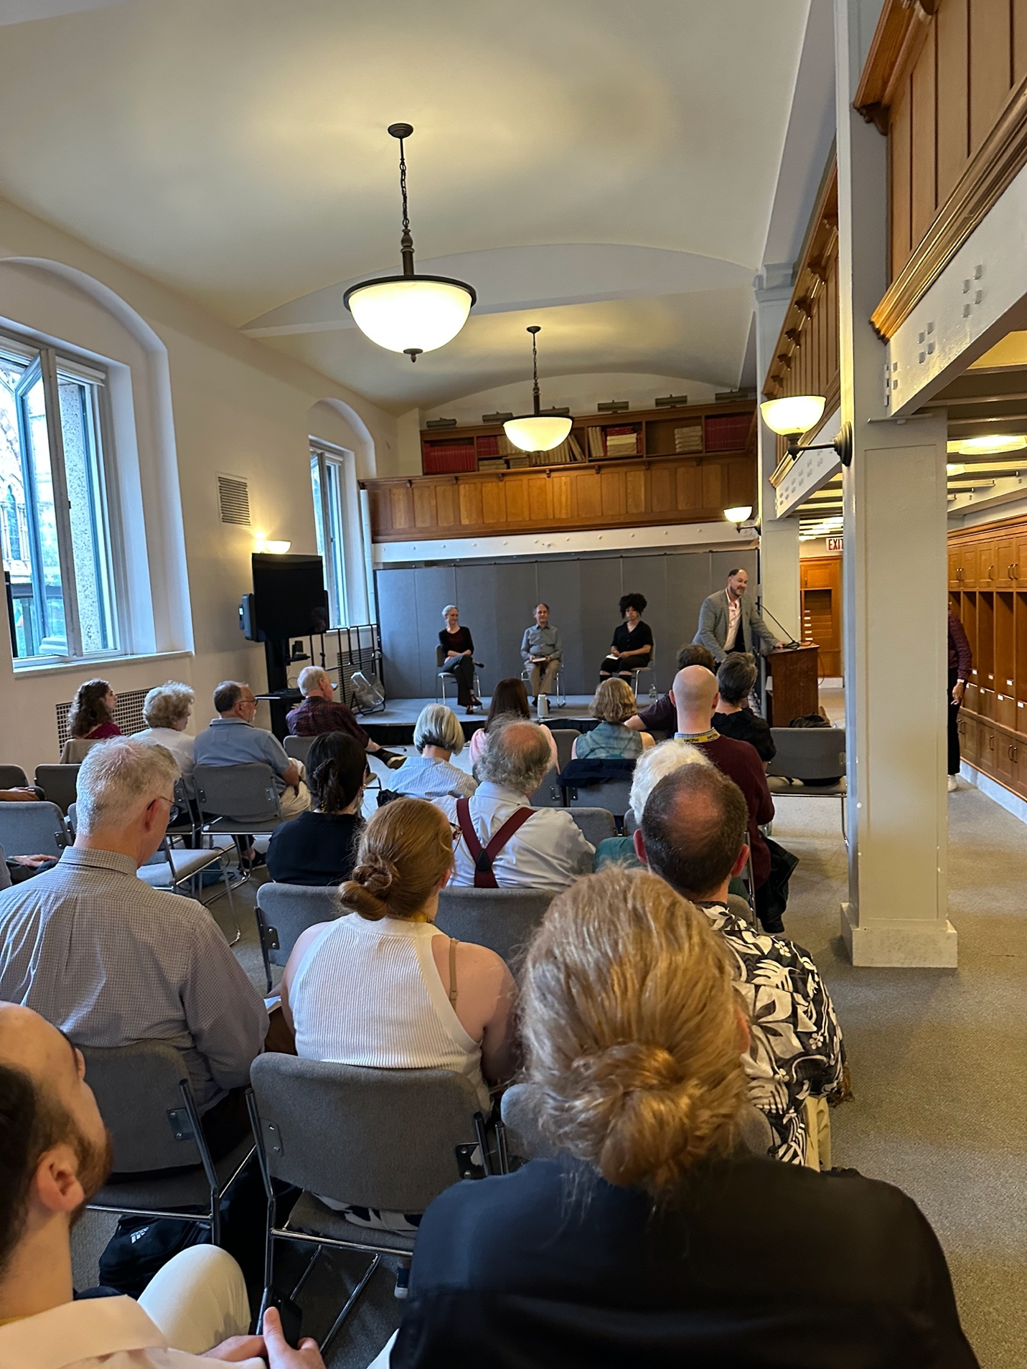

Questions and comments from members of our group enlivened the Q&A during the presentation.

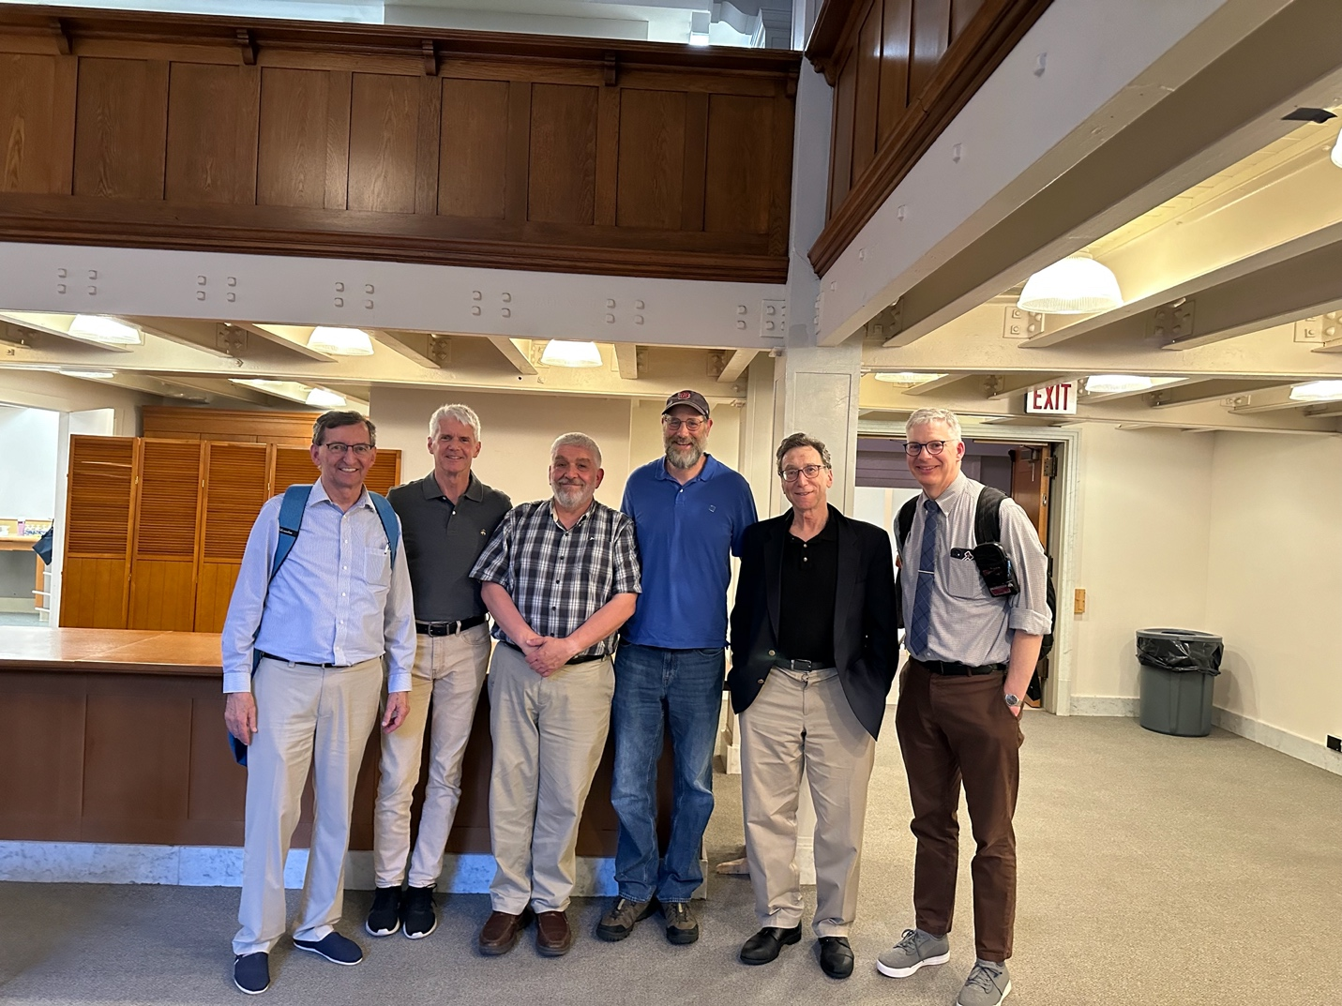
Left to right above: Rick Dower, John Sherry, Ken Cecire, Mike Wadness, Mike Hirsh, Mark Hedstrom.

Summer Workshop – August 20-21, 2024
This summer’s Boston QuarkNet Workshop was a substantial elaboration of our Relativity and GPS session on 12/12/2023, described above. We met in the Roxbury Latin Physics Lab and enjoyed subs and conversation over lunch both days at Deno’s. Participants included Gerry Gagnon, Mark Hedstrom, Tim Fitzgibbon, Mike Wadness, Dave Kurtz, Abe Phelps, Mike Hirsh, Scott Carlson, Kurt Murphy (Scott’s colleague at Winthrop H. S.), and Rick Dower.

On August 20, Rick reviewed the GPS satellite navigation system and the special and general relativistic corrections to the timing signals that ensure the accuracy of the resultant calculations in GPS receivers. We also looked at some history of the Relativity Principle, efforts to find an absolute reference frame in the “luminiferous aether,” Michelson-Morlet experiment, and derivation of Lorentz transformations. We watched the “Time Dilation: An Experiment with Mu Mesons” movie, as evidence of special relativistic time dilation and looked at evidence for gravitational time dilation. The QuarkNet Data Activity “Mean Lifetime Part II: Cosmic Muons” is an appropriate accompaniment to the film. The day concluded with a description of the relativistic corrections to the GPS clock times and a physics book give-away.

On August 21, the focus shifted to conservation laws, symmetry, and relativistic expressions for energy and momentum. We watched “The Ultimate Speed – An Experiment with High Energy Electrons,” and followed the derivation of E² = m² + p² for particles. We worked on the Data Activity “Calculate the Z Mass” to see the application of that relation. Rick will be posting the slides for his presentations on both days and some additional student exercises related to the presentations. We finished the day with our 25th Anniversary Boston QuarkNet cake.

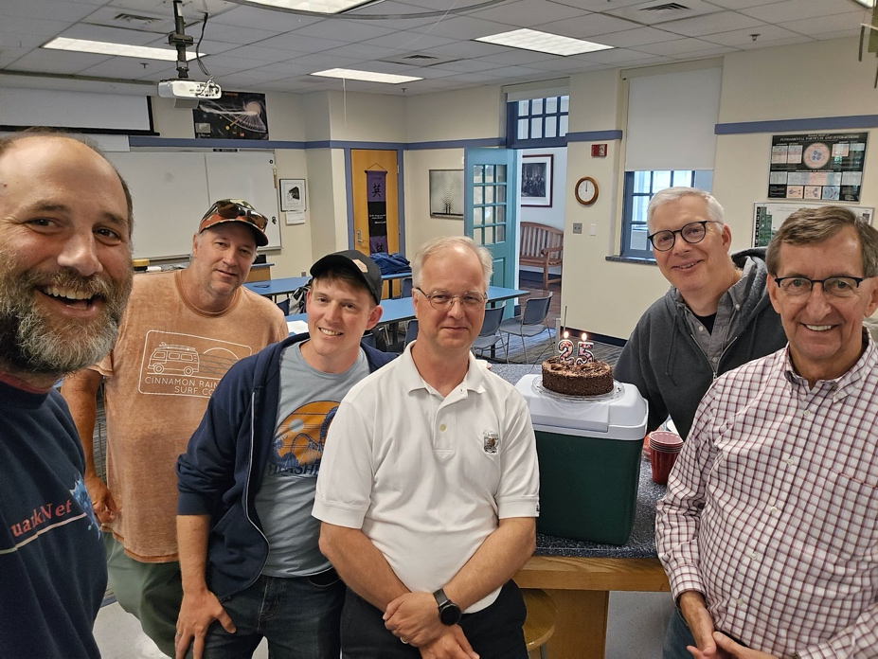
Left to right above: Mike Wadness, Kurt Murphy, Tim Fitzgibbon, Scott Sarlson, Mark Hedstrom, Rick Dower
Respectfully submitted,
Rick Dower

