Zenith Angle of Cosmic Ray Muons
Teacher Notes

Description
To investigate the muon rate as a function of zenith angle requires a cosmic ray detector in which a count of events per unit time can be made. The zenith angle is between the zenith and the normal to the plane of the counters.
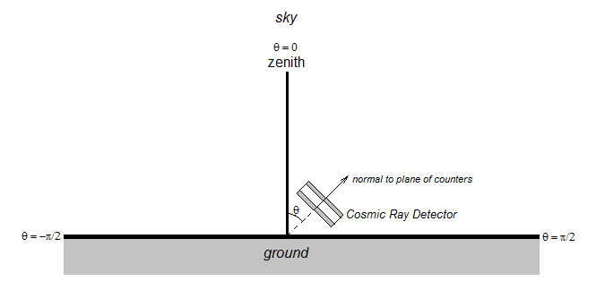
Students determine and record the cosmic ray rate at various zenith angles from θ = −π/2 to θ = π/2.. They plan where to do the measurements to get the best results and take note of any conditions aside from the natural rate of cosmic rays that may affect their results. They must consider and decide how to deal with uncertainties in measurement before and after they take measurements. They should plot the rates as a function of zenith angle and make a mathematical model and a physical interpretation of the plot.

Standards Addresses
Next Generation Science Standards
Science and Engineering Practices
2. Developing and using models
3. Planning and carrying out investigations
4. Analyzing and interpreting data
5. Using mathematics and analytical thinking
8. Obtaining, evaluating and communicating information
Crosscutting Concepts
Common Core Literacy Standards
Reading
9-12.4 Determine the meaning of symbols, key terms . . .
9-12.7 Translate quantitative or technical information . . .
Common Core Mathematics Standards
MP5. Use appropriate tools strategically.
MP6. Attend to precision.

Enduring Understanding
Physicists can measure cosmic rays and draw meaningful conclusions even though they are a phenomenon of unknown astrophysical origin.

Learning Objectives
As a result of this investigation, students will be able to:
- Take cosmic day data on a detector.
- Create a scatter plot and interpret the result.
- Evaluate the meaning of a plot based on a physical interpretation and understanding uncertainty.

Prior Knowledge
Students should be able to create graphs from data. A background in basic trigonometry helps but is not necessary.

Materials
Cosmic ray detector
Protractor
Timer, if not provided on cosmic ray detector
Optional: Frame to hold and rotate counters (see text under Implementation)

Background Material
If students are using a QuarkNet cosmic ray detector, be sure you are familiar with the detector: Users Manual - http://www.i2u2.org/cosmic/library/upload/b/ba/6000CRMDUserManual.pdf or http://quarknet.fnal.gov/toolkits/ati/det-user.pdf. If using a different detector, you need similar familiarity.

Resources
QuarkNet Cosmic Ray e-Lab resources: https://www.i2u2.org/elab/cosmic/library/resources.jsp.
“Determination of the Angular Distribution of Cosmic Rays at Sea Level” by Yi-Hong Kuo at http://dspace.mit.edu/bitstream/handle/1721.1/61208/701107722.pdf?sequence=1. Kuo’s Bachelor thesis gives an overview of experimental methods, the type of results one might expect and some explanation of the physics.

Implementation
Students design their investigation based on their hypothesis. In order to learn how their detector will perform taking one-minute counts, they need to practice with the detector facing straight up at the zenith. They will find the number of counts varies with each reading. This infomration will help them decide how many trials per angle and how many and which angles from –π/2 to π/2 they will use based on the time available, their understanding of uncertainty, and any physical limitations. If there are time and materials, they can build a rotating frame to hold the detector counters.
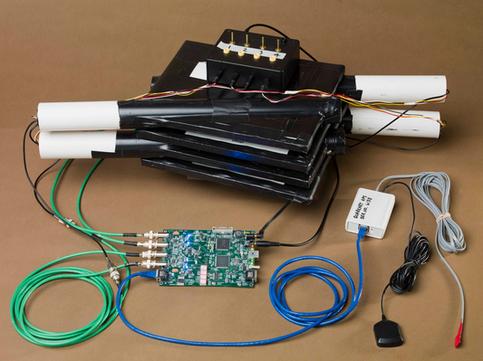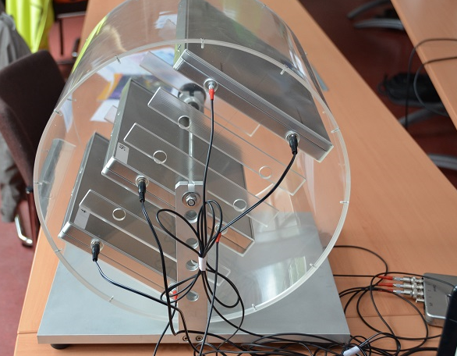
QuarkNet cosmic ray detector. Netzwerk Teilchenwelt zenith angle detector.

Students will record rates (counts/min) at each angle. They make a plot from this data. In an advanced version, students can also make plots of rates as a function of sin^{m}(nθ), cos^{m}(nθ), etc. where m and n are integers.

Note: Separating the counters to about 30 cm apart reduces the solid angle of acceptance and generally makes for a better fit of the data to the expected cos²θ function.

It is important for students to:
- Look for anamolies in the results that might relate to the physical situation. For example, if the detector points at a building or other dense object in part of its run, does this affect the result?
- Make a claim about the cosmic rays based on the data and what they already know. For example, do the results track with what they might expect based on atmospheric attenuation? Of where cosmic rays might come from? The claim can be tentative, that is, requiring further testing beyond this experiment; students should specify this in their report.
- Take into account and discuss uncertainty in measurements.

Optional: We ecnourage students to make a poster in the Cosmic Ray e-Lab at http://www.i2u2.org/elab/cosmic.

Assessment
Assessment in the first instance is based on claims, evidence, and reasoning. Students have a report to fill out in which they assess based on evidence and reasoning whether the claims made were accurate and how useful the results are.

