draft Heisenberg’s Laser draft
Teacher Notes

Description
The Heisenberg Uncertainty Principle is a long-established key component of quantum physics. It states that, for quantum particles, the uncertainties in measurement of complementary variables are inversely proportial to each other with a proportionality constant on the scale of Planck’s constant. The most famous example of such complementary variables is momentum p vs. position x: the more precisely we measure one, the greater the uncertainty in the other, expressed mathematically as Δp Δx ≥ h/2π. , where p is momentum, x is position (distance from some point) and h is Planck’s Constant, approximately 6.63 x 10⁻³⁴ Js or 4.14 x 10⁻¹⁴ eVs.
This activity is designed to enable students to empirically demonstrate the Uncertainty Principle by measuring the uncertainties in position and momentum of photons in a laser beam. To do this, we direct the laser through a small opening to enable diffraction. The size of the opening reveals Δx while the distance between maxima gives us Δp. Changing the size of the opening changes the distance between maxima.
Standards Addressed
Next Generation Science Standards
Science and Engineering Practices
4. Analyzing and interpreting data
5. Using mathematics and analytical thinking
8. Obtaining, evaluating and communicating information
Common Core Literacy Standards
Reading
9-12.4 Determine the meaning of symbols, key terms . . .
9-12.7 Translate quantitative or technical information . . .
Common Core Mathematics Standards
MP1. Make sense of problems and persevere in solving them.
MP2. Reason abstractly and quantitatively.
MP4. Model with mathematics.
Enduring Understanding
Scientists can use data to develop models based on patterns in the data.
Learning Objectives
Students be able to:
- Demonstrate diffraction of light from a laser beam passing through a thin slit.
- Show how changing the width of the slit changes the diffraction pattern.
- Apply the deBroglie wavelength equation and experimental results to empirically demonstrate the relationship between uncertainty in position and uncertainty in momentum.
Prior Knowledge
Students must be able to:
- Plot and interpret a graph from data.
- Read and adjust a vernier caliper.
- Apply the rules for diffraction.

Background Material
In the QuarkNet Data Activity What Heisenberg Knew, we use data from a beam of large molecules diffracting through a thin slit. These large molecules are still small enough to be quantum objects and so they create a wave-like diffraction pattern as they pass through the slit. The width of the slit provides an uncertainty in position of the molecules transverse to the beam direction. Since there is a width to each maximum or minimum there must be an uncertainty in the DeBroglie wavelength, implying an uncertainty in momentum, Students are give the data from this experiment and can confirm empirically that Δp = (constant)/Δx or ΔpΔx = constant, the mathematical expression of the Uncertainty Principle.
QuarkNet fellow Dr. Michael Wadness had an insight: what is physical for large molecules is physical for much smaller particles, like electrons. Electron diffraction experiments are well-know but beyond the capacities of high school physics laboratories to perform. Taking the logic a step further, however, perhaps the experiment can be performed with photons instead. This is not only what we propose but we also tested at the University of Notre Dame with the assistance of undergraduate laboratory manager Dr. Thomas Loughran.
Resources
What Heisenberg Knew from QuarkNet Data Activities portfolio

Materials
Data Images or
- Two Vernier Calipers that can be adjusted and read to mm precision
- Red laser, low intensity, with a known operating wavelength.
- Meter stick or similar length-measuring device
- White or light-colored screen (e.g. poster board)
- Stands and clamps to fix all items into place
- Room with sufficient space which can be darkened.
.
Implementation
Figure 1 shows the experiment as performed at Notre Dame. There are approaches to this activity. The first is to take the data from the Data Images pages, calculate values of Δp and Δx, and then plot the results. The second is similar but for the class to replicate the experiment and generate their own data. In the latter case, special care must be taken to train students in eye safety when using lasers.

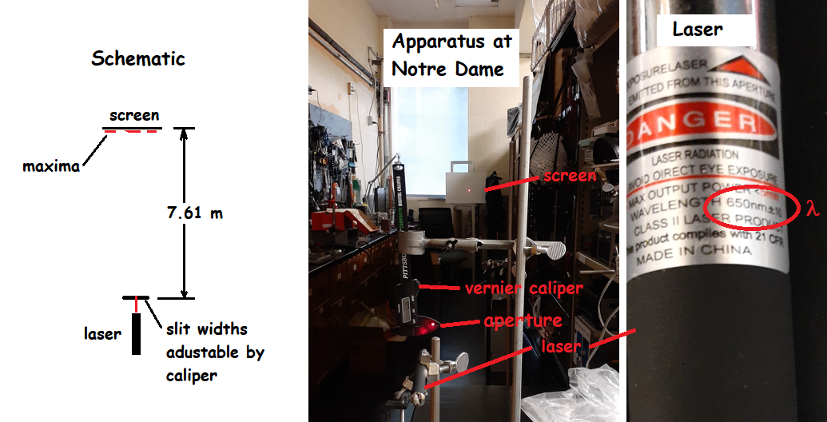
Figure 1. Experiment at Notre Dame.

In either case, these are the steps to perform the experiment and analyze results:
- Using stands and clamps place the laser in a horizontal position to send the beam some distance on the order of meters.
- Set up the caliper of that the plane of its slit opening is at right angles to the beam.
- Place the white or light-colored screen multiple meters away from the caliper with its plane vertical. Fix it in position.
- Adjust the caliper to 0.1 mm slit opening.
- Turn on the laser and adjust its position relative to the slit until you get a diffraction pattern on the screen.
- Using a different caliper, measure the width of the central maximum and record it.
- Repeat steps 4-6 multiple times, different slit opening widths up to 1 mm. If using the Data Images, students can read the caliper in the pictures.
After these steps are complete, students must determine Δp from the width of the central maximum and Δx from the size of the slit opening for each data point. It is preferable that Δp is calculated directly by students.

How to find Δp and Δx
It is not hard to get Δx: it is just the width of the aperture for the laser beam made by the vernier caliper at the source. Students can read it and record it. Finding Δp is a little more involved. To do this, we first treat the photon as if it is not a photon but a classical particle with velocity and mass. Then if it has this velocity in the beam direction, the width of the beam coming out of the slit would be due to variations in that velocity. As seen in the diagram below, we can call the speed of our particle v and the uncertainty (variation) in speed Δv perpendicular to v.
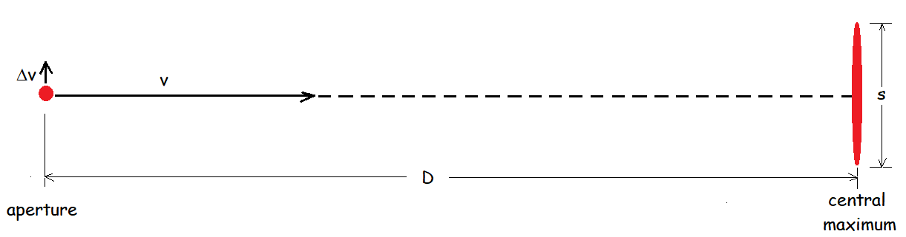
If the particle travels distance D to the screen in some time t, then
D = vt.
If the width of the central maximum in the diffraction pattern is understood to be s, then
s = 2(Δv)t.
Since, classically, p = mv and Δp = mΔv, we can rewrite these two equations as
D = (p/m)t
And
s = 2(Δp/m)t = 2(Δp)t/m.
Let’s divide the second equation by the first:
s/D = 2Δp/p
since the m’s and t’s all cancel. At this point we have an equation, since it only uses momentum p and no strictly classical quantities, works for photons, relativistic and quantum mechanical as they are.
Now we need to get a little more quantum mechanical: the deBroglie wavelength of the particle is λ = h/p, where h is Planck’s constant, 6.63 x 10⁻³⁴ kg̥-m²/s. We can rewrite this as p = h/λ and substitute into our developing equation:
s/D = 2 λΔp/h.
Rearranging for Δp, we get
Δp = hs/2λD.
Students can use this equation to find Δp for each measurement.
Sample calculation
Let’s make a sample calculation for an aperature 0.2 mm and width of central maximum s = 27 mm. The wavelength of the laser light is 650 nm and the distance from the aperature to the screen is 7.61 m. See below.
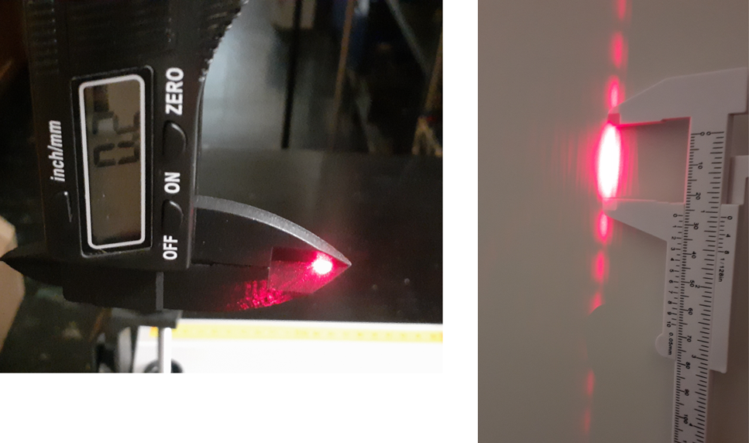
Then we can calculate Δp in this instance to be
Δp = hs/2λD = [(6.63 x 10⁻³⁴ kg-m²/s)(2.7 x 10⁻² m)]/[2(650x10⁻⁹ m)(7.61 m) = 1.81 x 10⁻³⁰ kg-m/s.
We can check this by seeing if it is approximately consistent with the Uncertainty relation
ΔpΔx = h/2π.
Let’s use it to calculate an approximate value of Planck’s Constant:
h = 2πΔpΔx = 2(3.14)(1.81 x 10⁻³⁰ kg-m/s)(2 x 10⁻⁴ m) = 2.27 x 10⁻³³ kg-m/s.
This is “in the ballpark” of h = 6.63 x 10⁻³⁴ kg-m²/s, which is about all we expect.

Expected results using supplied data
The results that can be read from the supplied data are summarized in this table:

Event | App (mm) | Width s (mm) | Width s (m) | delta x (m) | delta p (x 10^-30 kg-m/s) |  | 1/(delta x) (m^-1)
1 | 0.2 | 27 | 0.027 | 0.0002 | 1.81 |  | 5000
2 | 0.3 | 35 | 0.035 | 0.0003 | 2.35 |  | 3333
3 | 0.4 | 27 | 0.027 | 0.0004 | 1.81 |  | 2500
4 | 0.5 | 24 | 0.024 | 0.0005 | 1.61 |  | 2000
5 | 0.6 | 20 | 0.02 | 0.0006 | 1.34 |  | 1667
6 | 0.7 | 16 | 0.016 | 0.0007 | 1.07 |  | 1429
7 | 0.8 | 15 | 0.015 | 0.0008 | 1.01 |  | 1250
8 | 0.9 | 14 | 0.014 | 0.0009 | 0.94 |  | 1111
9 | 1 | 13 | 0.013 | 0.001 | 0.87 |  | 1000
Plotting Δp as a function of Δx, we get:

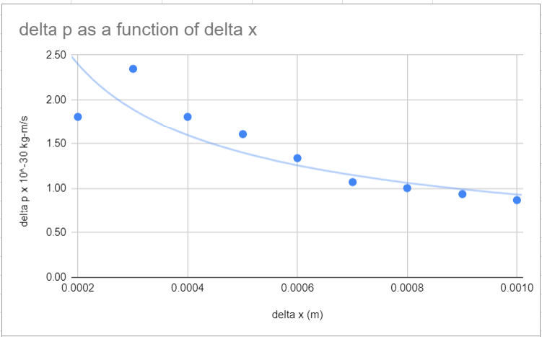

This is close to the expected curve – if ΔpΔx ~ h/2π, then as Δx increases, Δp decreases – but it is not perfect. We can see why in the linearized plot:

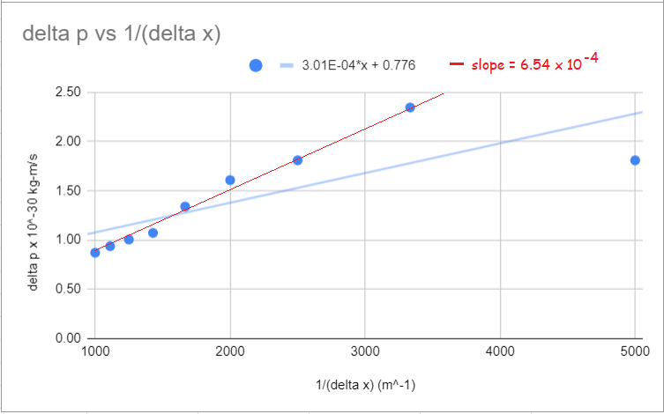

The last point seems to be an outlier. The blue trendline was generated by the software (Google sheets) and gives a slope of 3.01 x 10⁻³⁴ kg-m²/s once we take the scaling of the vertical axis into account. This is, as stated above in our sample calculation, “in the ballpark” The red trendline is more like a hand-drawn line that ignores the outlier. This slope is in the same ballpark.

You may run into this in doing the experiment with the students. If you use the pre-packaged data, then you do have this to deal with. How to analyze the plot becomes an item of discussion.
Stopped here…
Assessment
There are two main parts to the assessment:
- Student groups turn in their calculations and data tables for inspection.
- Each student should write a 1-2 paragraph description of how photons scatter off of electrons and, as a result, have a change in wavelength. They should relate this to momentum and energy considerations. Encourage diagrams.

Acknowledgement
This activity is based on an idea proposed by Michael Wadness, a QuarkNet LHC fellow in the Boston Center and physics teacher at Medford High School. Experimentation was developed with the kind assistance and guidance of Thomas Loughran of the Department of Physics and Astronomy at the University of Notre Dame.

