Separating Cosmic Ray Counters
(or: Where have all the Showers gone?)
Student Guide

We have a cosmic ray detector. Great! What can we do with it?

A cosmic ray detector counts cosmic ray muons coming from the upper atmosphere about 15 km above the surface of earth. The muons are actually secondary cosmic rays that come from primary cosmic rays from space colliding with nuclei in the atmosphere. Scientists are still investigating to determine where the primary cosmic rays come from and of which particles they are composed.
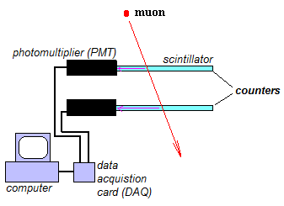
In the diagram to the right, a cosmic ray muon passes through two counters of a cosmic ray detector. The muon causes a faint flash of light in the scintillator of each counter. This light is converted to an electrical pulse and amplified in a PMT. The pulses from the two coutners go to the DAQ and the DAQ sends a count to the computer.

Most cosmic ray detectors are good for counting cosmic ray muons that cross through their counters. We will use that counting function to determine the rate (counts per minute) of muons coming hitting 2 separated cosmic ray counters in coincidence.
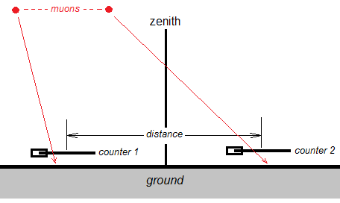
Diagram of our experimental set-up with a cosmic ray detector and 2 counters.

What do we know?
- Primary cosmic rays come from outer space. They collide with nuclei in the atmosphere. Secondary cosmic rays are produced in these collisions. We detect muons from the secondary cosmic rays.
- Our detector can count muons. With either an onboard timer or a stopwatch, we can find the muon rate in counts/sec.
- We can test to see if the rate varies as side-by-side counters are separated.
- There is uncertainty in measurement. We can manage the uncertainty with multiple trials and by quantifying it.

Learn about cosmic rays under Cosmic Ray Sites at https://www.i2u2.org/elab/cosmic/library/resources.jsp. For the basics, the Wikipedia article and Cosmic Extremes are especially helpful. The two links under Cosmic Ray Simulations are also recommended.

What tools do we need for our analysis?
We need our cosmic ray detector and a meter stick at minimum. We should also think about where best to site it to minimize confounding influences on our results. (For example, is there a nearby structure that might attenuate the cosmic rays?)

What will we do?
We will work in a team. The teacher will help us design and perform the experiment.

What are our claims? What is our evidence?
We claim that we can make one or both of these:
- We can find out if the muon rate changes as a result of changing the separation distance between counters in the same horizontal plane.
- With enough data at a sufficient number of separation distances, we can find in some detail how muon rate depends on this distance, if it does. Optionally, we can create a mathematical model of muon rate as a function of separation distance.
Once you have assembled your evidence and analyzed it, you can refine these claims and make them more specific. It is very important that we do this analysis as blind study. We must not aim at a known value or behavior but rather construct them from our data and our analysis.

After your class has discussed results, you should make a report on the provided form.

