How wide is my proton?
You are on shift to analyze actual events from the TOTEM detector
in the Large Hadron Collider at CERN.

Welcome to your TOTEM student operations shift. You will and your team will get a sample of actual prton scattering events from the TOTEM detector in the Large Hadron Collider (LHC). You will use this data with a bit of quantum physics and basic optics to find an upper limit to the “size” of the proton. In this case, by “size” we mean the diameter of the area of closest approach in which a proton can make an elastic collision with another proton. Inside this region the strong nuclear interaction has an increasing effect and collisions become more and more inelastic.

What do we know?
- The events we will use come from the collisions of protons at very high energies.
- Protons which scatter elastically will have very small scattering angles, which the TOTEM detector measures in microradians (μrad).
- The protons hit each other almost head-on; each proton has a momentum of 4 TeV/c or about 2.15x10⁻¹⁵ kg-m/s.
- Quantum mechanics tells us that a particle with momentum p has a wavelength λ=h/p where h is Planck’s constant, 6.63x10⁻³⁴ J-s.
- Basic optics tells us that when a wave of wavelength λ encounters a barrier of width d, a diffraction pattern is formed. Maxima can be found at angles θ_{n} where sin θ_{n} = nλ/d for n= 0, 1, 2, 3,… . For very small angles, sin θ_{n} ≈ θ_{n}, so θ_{n} ≈ nλ/d.
- TOTEM is really two detectors, hundreds of meters down the beam line from the collision point where the protons have scattered. For any one event, we can read the scattering angle for each of two protons. We must record both.

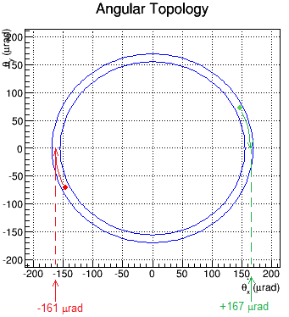
This Sample Event shows the main features of the events you will see. The details of each event will vary, of course.

The TOTEM detectors are embedded into the edges of the LHC beam pipe. Each records a “hit” where a scattered proton strikes. The red and green dots represent these hits.

The event display shows a planar view, with the beam occupying an area in the middle; there is a gap in the detector here. By tracing each dot to the “θ_{x}-axis” we can find the value of scattering angle θ in μrad.

Learn about:
- The Large Hadron Collider from CERN in 3 minutes at https://www.youtube.com/watch?v=2jup2R9Jtnc.
- Learn about TOTEM on their website at http://totem-experiment.web.cern.ch/totem-experiment/ and in the video at https://www.youtube.com/watch?v=YsZhwu32Zaw.
- DeBroglie wavelength at http://en.wikipedia.org/wiki/Matter_wave.
- Diffraction at http://en.wikipedia.org/wiki/Diffraction.

What tools do we need for our analysis?
We need:
- our data file at https://quarknet.i2u2.org/sites/default/files/totem_events_sm_1.pdf
- the data tally sheet at https://quarknet.i2u2.org/sites/default/files/totem_tally.pdf
- a way to make a histogram of scattering angles from -240 to +240 μrad with bin widths of 10 μrad.
A straight edge and a graphing calculator are also helpful.

What will we do?
We will work in pairs. The shift manager will help us determine which events to examine, which analyses to do, and how to incorporate our results into overall results for the entire team.

What are our claims? What is our evidence?
We claim:
- The individual scattering angles of protons, taken together in a histogram, will reveal a diffraction pattern, thus showing that, as deBroglie predicted, quantum objects such as protons can behave as waves.
- We can use this to find an upper limit to the size of a proton based on the diameter of its elastic scattering cross-section.
Once you have assembled your evidence and analyzed it, you can refine these claims and make them more specific. It is very important that we do this analysis as blind study. We must not aim at a known value but rather construct the value from our data and our analysis. We will hand these results over to the shift manager to create the best possible measurement.

After your class has discussed results, you may make your TOTEM Student Operations Shift Report.

