TOTEM Data Express
You are on shift to analyze events from the TOTEM detector
in the Large Hadron Collider at CERN.

Welcome to your operations shift. Your team will be studying proton scattering events from the TOTEM detector in the Large Hadron Collider (LHC). You will use this data with a bit of quantum physics and basic optics to find an upper limit to the “size” of the proton. In this case, size means the diameter of the area of closest approach in which a proton can make an elastic collision (kinetic energy is conserved) with another proton. Inside this region the strong nuclear interaction has an increasing effect and collisions become more and more inelastic (kinetic energy is not conserved).

What do we know?
- Our events come from very high-energy proton collisions.
- Protons that scatter elastically have very small scattering angles that TOTEM measures in microradians (μrad).
- The protons hit each other almost head-on; each proton has a momentum of 4 TeV/c or about 2.15x10⁻¹⁵ kg-m/s.
- Quantum mechanics tells us that a particle with momentum p has a wavelength λ=h/p where h is Planck’s constant, 6.63x10⁻³⁴ J-s or 4.1x10⁻¹⁵ eV-s.
- Basic optics tells us that when a wave of wavelength l encounters a barrier of width d, a diffraction pattern is formed. Maxima can be found at angles θ_{n} where sin θ_{n} = nλ/d for n= 0, 1, 2, 3,… . For very small angles, sin θ_{n} ≈ θ_{n}, so θ_{n} ≈ nλ/d.
- TOTEM is really two detectors hundreds of meters down the beam line from the collision point where the protons have scattered. For each event, we read the scattering angle for each of two protons. We must record both.

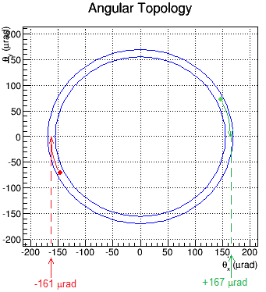
This sample event shows the main features of events in general. The details of each will vary, of course.

The TOTEM detectors are embedded into the edges of the LHC beam pipe. Each records a “hit” where a scattered proton strikes. The red and green dots represent these hits.

This event display shows a planar view, with the beam occupying an area in the middle where there is a gap in the detector. By tracing each dot to the “θ_{x}-axis” we can find the value of scattering angle θ in μrad.

Learn about:
- The Large Hadron Collider from CERN in 3 minutes: https://www.youtube.com/watch?v=2jup2R9Jtnc.
- TOTEM on their website: http://totem-experiment.web.cern.ch/totem-experiment/ and in the video: https://www.youtube.com/watch?v=YsZhwu32Zaw.
- DeBroglie wavelength: http://en.wikipedia.org/wiki/Matter_wave.
- Diffraction: http://en.wikipedia.org/wiki/Diffraction.

What analysis tools do we need?
- Our data file: https://quarknet.i2u2.org/sites/default/files/totem_events_sm_1.pdf
- The data tally sheet: https://quarknet.i2u2.org/sites/default/files/totem_tally.pdf
- A way to make a histogram of scattering angles from -240 to +240 μrad with bin widths of 10 μrad.
A straight edge and graphing calculator are also useful.

What do we do?
We work in pairs. The shift manager assigns us events to examine, which analyses to do, and how to incorporate our results into results for the entire team.

What are our claims? What is our evidence?
Develop claims based on your team’s data. You may have evidence regarding the wave behavior of protons and/or an upper limit to the “size” of a proton.
It is very important that we do this analysis as a blind study. We must not aim for a known value but rather construct the value from our data and our analysis. We will hand these results over to the shift manager to create the best possible measurement.
Discuss the explanation behind your claims and evidence. After your class discussion, prepare your TOTEM Student Operations Shift Report.

