How wide is my proton?
Teacher Notes

Description
How wide is my proton? is a short investigation using events from the TOTEM detectors system at the Large Hadron Collider (LHC). Students inspect the events and find the elastic scattering angles of protons which collide at Point 5.

Standards Addressed
Next Generation Science Standards
Science and Engineering Practices
4. Analyzing and interpreting data
5. Using mathematics and analytical thinking
8. Obtaining, evaluating and communicating information
Crosscutting Concepts
Common Core Literacy Standards
Reading
9-12.4 Determine the meaning of symbols, key terms . . .
9-12.7 Translate quantitative or technical information . . .
Common Core Mathematics Standards
MP1. Make sense of problems and persevere in solving them.
MP2. Reason abstractly and quantitatively.
MP4. Model with mathematics.

Enduring Understanding
Quantum objects that we call particles behave as waves; we can measure this behavior and use it to study these particles.

Learning Objectives
Students will know and be able to:
- Create and interpret a histogram from data.
- Apply diffraction of waves and deBroglie wavelength to calculate an upper limit to the size of a proton.

Prior Knowledge
Students should have studied momentum and energy at least in classical mechanics and wave diffraction in optics.

Background Material
These resources on TOTEM, the LHC, and physics related to the activity are available on the student pages:
- The Large Hadron Collider from CERN in 3 minutes at https://www.youtube.com/watch?v=2jup2R9Jtnc.
- Learn about TOTEM on their website at http://totem-experiment.web.cern.ch/totem-experiment/ and in the video at https://www.youtube.com/watch?v=YsZhwu32Zaw.
- DeBroglie wavelength at http://en.wikipedia.org/wiki/Matter_wave.
- Diffraction at http://en.wikipedia.org/wiki/Diffraction.

Resources
Data file: https://quarknet.i2u2.org/sites/default/files/totem_events_sm_1.pdf.
Tally sheet: https://quarknet.i2u2.org/sites/default/files/totem_tally.pdf.
Provide a method for the whole class to make a histogram from -240 μrad to +240 μrad with a 10 μrad bin width (see tally sheet). A preferred method is to create space with marked axes (scattering angle horizontal, number of events vertical) onto which students can add a post-it for each event in each bin. See the next section for an example.

Implementation
In the student pages, students have enough information to calculate the deBroglie wavelength of a 4 TeV proton. This calculation can be done as homework before the actual activity or at the beginning of the activity at the discretion of the teacher. The result should be around 2.9x10⁻¹³ μm.

There are 21 pages of events in the data file, 2 events per page. It is best if students work in pairs to check each other and that each pair of students has 6 or more events to analyze. The data file is in pdf format, so the events can be printed or viewed on computers. Oversampling (more than one pair of students with the same data) is expected.

Students analyze events by locating the red dot and the green dot in each event. Each of these dots represents a detected scattered proton on one side of the collision or the other, over 200 m along the beam line from the collision point. Students read the scattering angle by following the circle which frames the dots to the horizontal θ_{x}-axis. This will be the scattering angle. See below.

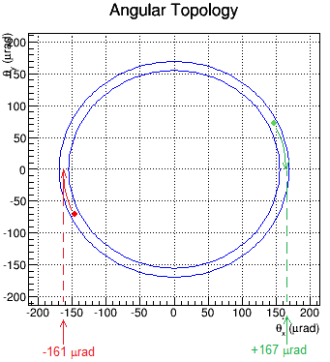
This Sample Event shows the main features of the events you will see. The details of each event will vary, of course.

The TOTEM detectors are embedded into the edges of the LHC beam pipe. Each records a “hit” where a scattered proton strikes. The red and green dots represent these hits.

The event display shows a planar view, with the beam occupying an area in the middle; there is a gap in the detector here. By tracing each dot to the “θ_{x}-axis” we can find the value of scattering angle θ in μrad.

In general, the scattering angles for the red and green dots in any given event will be very close to each other. If we encourage students to notice this, they might be able to conclude (correctly) that this is a result of the conservation of momentum. This also means that if we measure the momentum of a proton at the detector on one side of the collision, we then know the momentum of the proton on the other side, over 400 m away – a simple version of quantum entanglement.

Students should record results in the tally sheet. Here is an example:
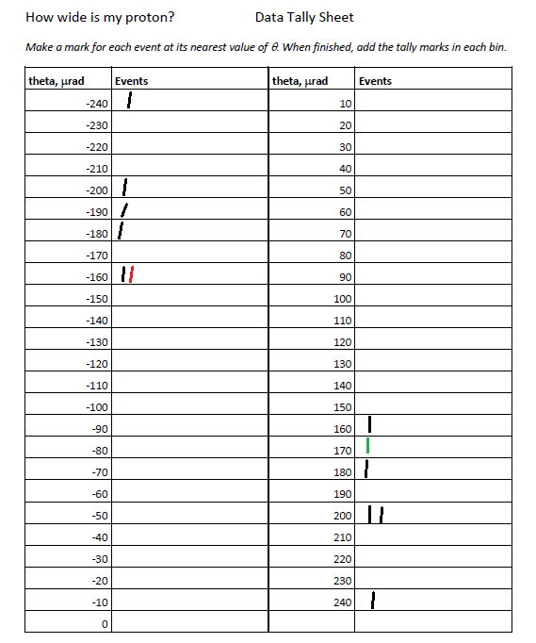
An example of the Data Tally sheet is to the left. The students have examined 6 events, each with a positive and a negative scattering angle falling into one of the bins. Each bin is 10 μrad wide and centered on a multiple of 10; this students can round to the nearest multiple of ten and put the mark near that angle.

The angles from the sample above are included and colored red and green so they stand out for the reader. (Students do not need to color code results.)

Students use their results – the number of data marks they have at each scattering angle – to fill in a histogram for the whole class. One way to do this is to use “sticky notes” on a prepared space, as below.

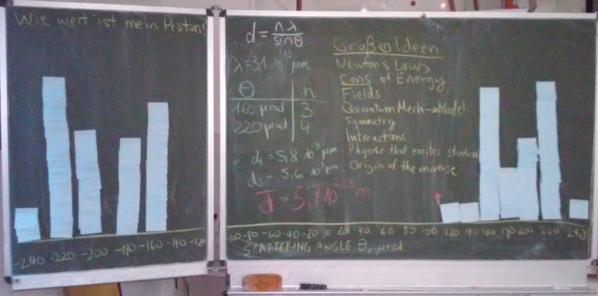
Results in a workshop for pre-service teachers, Technische Universität Dresden.
Note that there is a gap in the data representing a physical limit of the detector.

Students then need to identify the peaks. The teacher should encourage them to note that the middle of the distribution is empty because the detector cannot enter the region of the beam. (Using the “blocked off angles and a distance of 220 m, students can estimate an upper limit to the width of the beam in the LHC.) They then can use this to estimate the value of n for each peak and use it to calculate an upper limit to the diameter of the proton. Students can do this in small groups, each using a peak, and then compare the results. Generally, they should normally get about 5-8 times the published proton diameter of about 0.88 fm or 8.8x10⁻¹⁶ m. If possible, please discuss why they get the larger value and what is meant by the “diameter” of a quantum object like a proton.

Assessment
Assessment is based on claims, evidence, and reasoning. Students complete a “Shift Report” in which they assess based on evidence and reasoning the accuracy of the claims and how useful the results are.

