TOTEM Data Express
Teacher Notes

Description
In this short investigation students inspect events from the TOTEM sub-detectors system at the Large Hadron Collider (LHC) to find the elastic scattering angles of protons that collide at Point 5.

Standards Addressed
Next Generation Science Standards
Science and Engineering Practices
4. Analyzing and interpreting data
5. Using mathematics and analytical thinking
8. Obtaining, evaluating and communicating information

Common Core Literacy Standards
Reading
9-12.4 Determine the meaning of symbols, key terms . . .
9-12.7 Translate quantitative or technical information . . .
Common Core Mathematics Standards
MP1. Make sense of problems and persevere in solving them.
MP2. Reason abstractly and quantitatively.
MP4. Model with mathematics.

Enduring Understanding
Quantum objects that we call particles behave as waves; we can measure this behavior quantitatively and use data to construct models of the structure of matter as well as the interactions between matter.

Learning Objectives
Students will know and be able to:
- Create and interpret a histogram from data.
- Apply diffraction of waves and deBroglie wavelength to calculate an upper limit to the size of a proton.

Prior Knowledge
Students must be able to plot and interpret a graph from data and have a working understanding of momentum and energy in classical mechanics and wave diffraction in optics.

Background Material
These resources on TOTEM, the LHC, and the physics related to the activity are included on the student pages:
- The LHC from CERN in 3 minutes: https://www.youtube.com/watch?v=2jup2R9Jtnc.
- TOTEM on their website: http://totem-experiment.web.cern.ch/totem-experiment/ and in the video: https://www.youtube.com/watch?v=YsZhwu32Zaw.
- DeBroglie wavelength: http://en.wikipedia.org/wiki/Matter_wave.
- Diffraction: http://en.wikipedia.org/wiki/Diffraction.

Resources
Data file: https://quarknet.i2u2.org/sites/default/files/totem_events_sm_1.pdf.
Tally sheet: https://quarknet.i2u2.org/sites/default/files/totem_tally.pdf.
Provide a method for the whole class to make a histogram from -240 μrad to +240 μrad with a 10 μrad bin width (see tally sheet). A preferred method is to create space with marked axes (scattering angle horizontal, number of events vertical) onto which students add a post-it for each event in the appropriate bin. See the next section for an example.

Implementation
We provide enough information for students to calculate the deBroglie wavelength of a 4 TeV proton. They can do this calculation as homework before the activity or at the beginning of the activity at your discretion. The result should be around 3.2x10⁻¹³ μm.

The data file contains 21 pages of events, 2 events per page. Students work in pairs to analyze six or more events. The data file is in pdf format, so you can print the events or students can view them on computers. Plan to oversample the data—more than one pair of students should analyze the same data.

Students analyze events by locating the red dot and the green dot in each event. Each dot represents a detected scattered proton on one side of the collision or the other, that are over 200 m along the beam line from the collision point. Students read the scattering angle by following the circle that frames the dots to the horizontal θ_{x}-axis. This will be the scattering angle. See below.

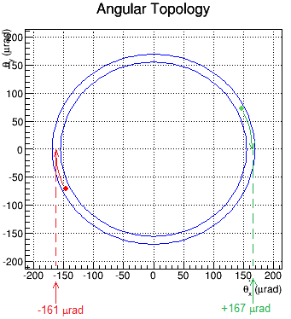
This sample event shows the main features of an event. The details of each event will vary.

The TOTEM detectors are embedded into the edges of the LHC beam pipe. Each records a “hit” where a scattered proton strikes. The red and green dots represent these hits.

The event display shows a planar view, with the beam occupying an area in the middle; there is a gap in the detector here. By tracing each dot to the “θ_{x}-axis” we can find the value of scattering angle θ in μrad.

In general, the scattering angles for the red and green dots in any given event will be very close to each other. If you guide students to notice this, they might be able to conclude (correctly) that this is a result of conservation of momentum. This also means that if we measure the momentum of a proton at the detector on one side of the collision, we know the momentum of the proton on the other side, over 400 m away—a simple version of quantum entanglement.

Students record results in the tally sheet. Here is an example:
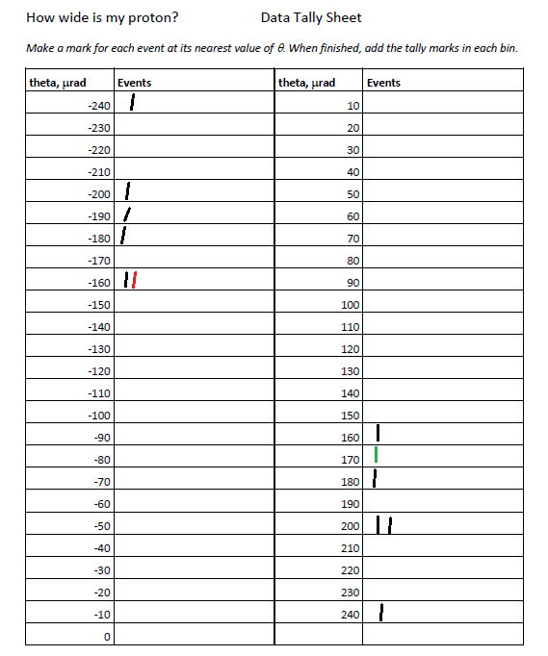
In this sample data tally sheet students have examined six events, each with a positive and a negative scattering angle and recorded them in one of the bins. Each bin is 10 μrad wide centered on a multiple of 10; students round to the nearest multiple of ten to record the data.

The angles from the sample are colored red and green so they stand out for you. (Students do not need to color code results.)

Students use their results—the number of data marks they have at each scattering angle—to fill in a histogram for the whole class. One way to do this is to use “sticky notes” on a prepared space, as below.

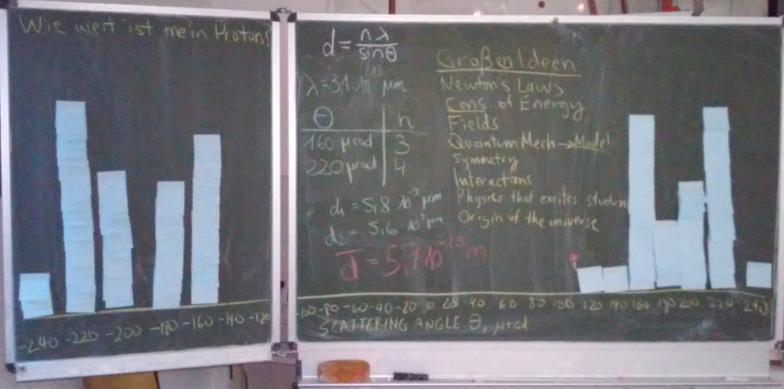
Results in a workshop for pre-service teachers, Technische Universität Dresden.
Note the gap in the data representing a physical limit of the detector.

To analyze the data, students identify the peaks. Guide them to note that the middle of the distribution is empty because the detector cannot enter the region of the beam. (Using the “blocked off angles and a distance of 220 m, students can estimate an upper limit to the width of the LHC beam.) They use this gap and the angular distance between adjacent peaks to estimate the value of n for each peak; they n, θ, and λ to calculate an upper limit to the diameter d of the proton. Students can do this in small groups, each using a peak, and then compare the results. Generally, they should get about 3-5 times the published proton diameter of about 1.8 fm or 1.8x10⁻¹⁵ m. If possible, discuss why they get the larger value and what is meant by the “diameter” of a quantum object like a proton. The interaction diameter for elastic scattering of a proton is greater than the published “charge diameter” measured from scattering of electrons off protons.

Sample calculation:
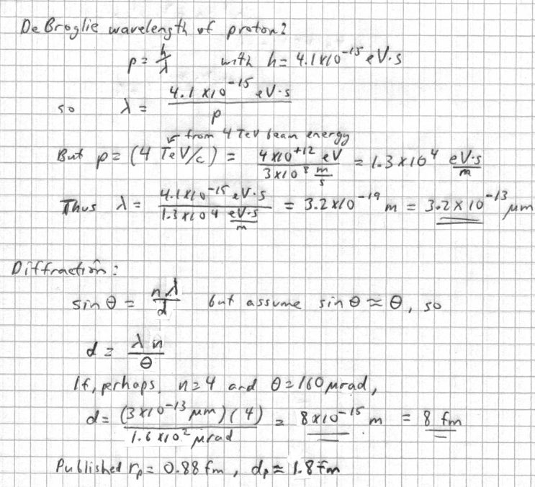

Assessment
Assessment is based on claims, evidence, and reasoning. Students complete a “Shift Report” in which they assess the accuracy of the claims and how useful the results are based on evidence and reasoning.

Claims we hope the students will be able to make based on the evidence they build:

- The scattering angles of individual protons, plotted altogether in a histogram reveal a diffraction pattern, showing, as deBroglie predicted, that quantum objects such as protons can behave as waves.
- We use this to find an upper limit to the size of a proton based on the diameter of its elastic scattering cross-section.

