TOTEM Data Express
Student Guide

How big is a proton? What do you need to figure this out? You and your fellow students will use actual data from the TOTEM detector system in the Large Hadron Collider (LHC) at CERN, some basic physics, and just a little insight from quantum mechanics to estimate the upper limit – the largest possible value – of the diameter of the proton.

What do we know?
- TOTEM events come from very high-energy proton collisions.
- If these protons do not come close enough to each other to interact via the strong nuclear force, then they will simply scatter elastically as though they were rubber balls. Protons that scatter elastically, therefore, have very small scattering angles that TOTEM measures in microradians (μrad).
- The protons hit each other almost head-on; each proton has a momentum of approximately 2.15 x 10⁻¹⁵ kg-m/s (or, in particle physics units, 4 TeV/c).
- In the quantum world, where a particle can be modeled as a wave, its momentum is directly proportional to its frequency rather than its speed.
- If the proton can be modeled as a wave, then protons will diffract when they scatter elastically. The size of the target, d, and the wavelength of the wave, λ, will affect the diffraction angle.
- TOTEM is two detectors hundreds of meters down the beam line from the collision point where the protons have scattered. For each event, you read the scattering angle for each of two protons. You must record both.

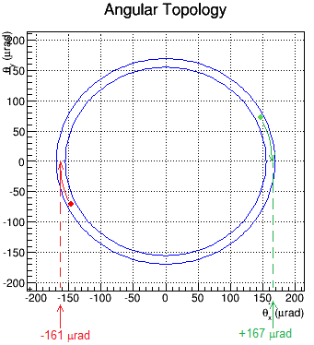
This sample event shows the main features of events in general. The details of each will vary, of course.

The TOTEM detectors are embedded into the edges of the LHC beam pipe. Each records a “hit” where a scattered proton strikes. The red and green dots represent these hits.

This event display shows a planar view, with the beam occupying an area in the middle where there is a gap in the detector.

As you can see, the protons scatter in both the X- and Y-directions, so calculating the true scattering angle would ordinarily be a vector operation. However, we can simplify this by rotating our perspective, i.e. tracing each dot to the “θ_{x}-axis.”As you can see in the figure, by doing this rotation we can just read the value of θ directly off the θ_{x} axis.

Learn about:
- The Large Hadron Collider from CERN in 3 minutes: https://www.youtube.com/watch?v=2jup2R9Jtnc.
- TOTEM:
  - Experiment home page: http://totem-experiment.web.cern.ch/totem-experiment/
  - Explanatory video: https://www.youtube.com/watch?v=YsZhwu32Zaw.
- DeBroglie wavelength:
  - http://en.wikipedia.org/wiki/Matter_wave.
  - http://hyperphysics.phy-astr.gsu.edu/hbase/quantum/debrog2.html
  - http://scienceworld.wolfram.com/physics/deBroglieWavelength.html
- Diffraction:
  - http://en.wikipedia.org/wiki/Diffraction.
  - http://hyperphysics.phy-astr.gsu.edu/hbase/phyopt/diffracon.html#c1
  - http://www.physicsclassroom.com/class/light/Lesson-1/Wavelike-Behaviors-of-Light

What analysis tools do we need?
- Our data file: https://quarknet.i2u2.org/sites/default/files/totem_events_sm_1.pdf
- The data tally sheet: https://quarknet.i2u2.org/sites/default/files/totem_tally.pdf
- A way to make a histogram of scattering angles from -240 to +240 μrad with bin widths of 10 μrad.
- A straight edge and graphing calculator are useful.

What do we do?
Students work in pairs. Your teacher will assigns you events to examine, which analyses to do, and how to incorporate our results into results for the entire team. The goal, as stated in the introduction, is to state and support the assertion that we can use these experimental data to estimate the upper limit of the diameter of the proton.

What are our claims? What is our evidence?
Develop claims based on your team’s data. You may have evidence regarding the wave behavior of protons and, using this, an upper limit to the “size” of a proton.
It is very important that you and your fellows students do this analysis as a blind study. Do not aim for a known value but rather construct the value from our data and our analysis. You combine your results with those of other students to create the best possible measurement.
Provide a clear connection between your claims and the evidence to support them. After your class discussion, prepare your TOTEM Student Report.

